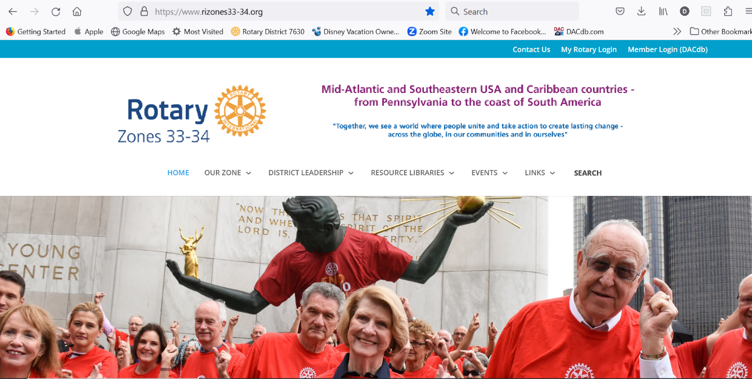
https://www.rizones33-34.org/
In SEARCH put one key word for what you are looking for – i.e. Discover or Prospect
https://www.rizones33-34.org/?s=tool
Public Image – PI is a big part of growing our club’s community impact. Post pictures or short videos to your Facebook, LinkedIn, Instagram or other social media site.
ADD Hash Tags –
#RID7630
#Rotary
#your club’s name
#rotaryinternational #serviceaboveself
#rotaryinaction #createhopeintheworld
#rotaryrocks #rotarymembers
#joinrotary #discoverrotary
Membership helpers:
DG John Mager – jmager@bumpersco.com – 302-7402197
DMC Gary King - delmarvacoins@gmail.com – 443-880-2564
DICC Pat Campbell-White – patcampbellwhite@gmail.com – 302-542-1488
MAP Ambassador Cliff Berg – cliff0917@aol.com – 302-540-2127
ARC Hugh Dawkins – dawkins@goeaston.net – 410-310-2997

